Survey on Real Time Wireframe Pothole Detection System
Dr RG Suresh Kumar¹, Mohamed B Sirajuddeen²
¹Professor & HoD, Department of Computer Science and Engineering, Rajiv Gandhi College of Engineering and Technology, Puducherry, 607 403, India
²Student, Department of Computer Science and Engineering, Rajiv Gandhi College of Engineering and Technology, Puducherry, 607 403, India
Emails: aargeek@gmail.com¹, mohamedbsirajuddeen@gmail.com²
Abstract
Road surface irregularities like potholes present major risks to vehicle safety, passenger comfort, and the efficiency of traffic flow. These issues have significant implications in the transportation domain, as they directly affect road safety, traffic management, and overall driving experience. With the growth of autonomous vehicles and smart city initiatives, the need for intelligent systems that can accurately detect and analyze road conditions in real time has become increasingly important.
Traditional approaches for pothole detection have been enhanced through the integration of computer vision and artificial intelligence. These systems utilize cameras to capture road images, which are then processed using deep learning models to detect and classify potholes. By applying AI-based image analysis, the existing methods effectively automate the identification of road surface irregularities, offering a faster and more efficient alternative to manual inspections and sensor-based techniques. The limitation in existing systems is their reliance on two-dimensional bounding boxes or simple classification, which lack depth and shape information.
To address this limitation, my project proposes a Real-Time Wireframe Pothole Detection System that generates a three-dimensional wireframe of road surfaces using camera input. The proposed model aims to integrate depth estimation with wireframe modeling for precise analysis of surface irregularities, enabling better decisions for autonomous vehicles and improving road safety.
Keywords: Computer vision ; Deep learning ; Pothole detection ‘ Real-time detection ; Wireframe modeling

- INTRODUCTION
Road surface deterioration, particularly pothole formation, remains a persistent issue affecting transportation safety, vehicle longevity, and traffic efficiency. In conventional traffic systems, potholes are typically identified through manual inspection or post-event maintenance reporting, which is time-consuming and inconsistent. With the rise of autonomous vehicles, reliable and real-time road surface perception has become essential for safe navigation and adaptive control.
Early autonomous driving research primarily focused on object detection, obstacle avoidance, and scene understanding (Thrun et al., 2006; Geiger et al., 2012). While these works established strong perception benchmarks, detailed modeling of road surface anomalies received limited attention. As autonomous systems matured, attention shifted toward detecting smaller but safety-critical surface irregularities such as potholes.
  - Vision-Based Pothole Detection
The adoption of deep learning significantly advanced automated pothole detection. Convolutional neural networks and real-time object detectors such as YOLO enabled fast and accurate localization of road defects from RGB images (Redmon et al., 2016; Bochkovskiy et al., 2020). Subsequent improvements incorporated attention mechanisms and segmentation models to refine boundary accuracy and robustness under varying illumination conditions (Maeda et al., 2018; Yurdakul and Taşdemir, 2025).

Despite these improvements, most vision-based systems remain limited to two-dimensional representations. Bounding boxes or segmentation masks identify pothole regions but fail to capture depth, slope, or structural severity. For autonomous navigation, knowing the geometric impact of a pothole is more critical than merely detecting its presence.
  - Depth Aware and Sensor Fusion Approaches
To overcome 2D limitations, several studies integrated LiDAR or RGB-D sensors for geometric characterization (Newcombe et al., 2011; Meerits et al., 2019; Karukayil et al., 2024). These systems enable accurate depth estimation and volume computation using point clouds and mesh reconstruction techniques.

However, sensor-fusion architectures introduce high hardware costs, calibration challenges, increased power consumption, and scalability limitations. Moreover, many of these systems are optimized for infrastructure monitoring rather than low-latency decision support for autonomous vehicles.

Recent advancements in monocular depth estimation demonstrate that 3D structure can be inferred from a single RGB camera (Eigen et al., 2014; Ranftl et al., 2022). This development provides a cost-effective alternative to LiDAR-based depth sensing and enables the possibility of geometry-aware perception without additional sensors.
- METHOD (12 pt)
The Methods sections should be brief, but they should include sufficient technical information to allow the experiments to be repeated by a qualified reader. Only new methods should be described in detail. Cite previously published procedures in References.
Tables and Figures are presented center, as shown below and cited in the manuscript.
Table 1. Experimental input parameters for EDM
EDM TOOL | VOLTAGE  (v) | PULSE ON(µs)
Aluminum | 11 | 12
Copper | 22 | 44
Graphite | 33 | 10
Composite | 45 | 66
Aluminum | 11 | 12
Copper | 22 | 44
Graphite | 33 | 10
Composite | 45 | 66
Aluminum | 11 | 12
Copper | 22 | 44
Graphite | 33 | 10
Composite | 45 | 66

  - Tables
Tables should be typewritten separately from the main text and preferably in an appropriate font size to fit each table on a separate page. Each table must be numbered with Arabic numerals (e.g., Table 1, Table 2) and include a title. Place footnotes to tables below the table body and indicate them with superscript lowercase letters (a, b, c, etc.), not symbols. Do not use vertical rulings in the tables. Each column in a table must have a heading, and abbreviations, when necessary, should be defined in the footnotes.
  - Figures
Figures should be provided separately from the main text. Use Arabic numerals to number all figures (e.g., Figure 1, Figure 2) according to their sequence in the text. The figure number must appear well outside the boundaries of the image itself. Multipart figures should be indicated with uppercase and bold font letters (A, B, C, etc.) without parenthesis, both on the figure itself and in the figure legends.
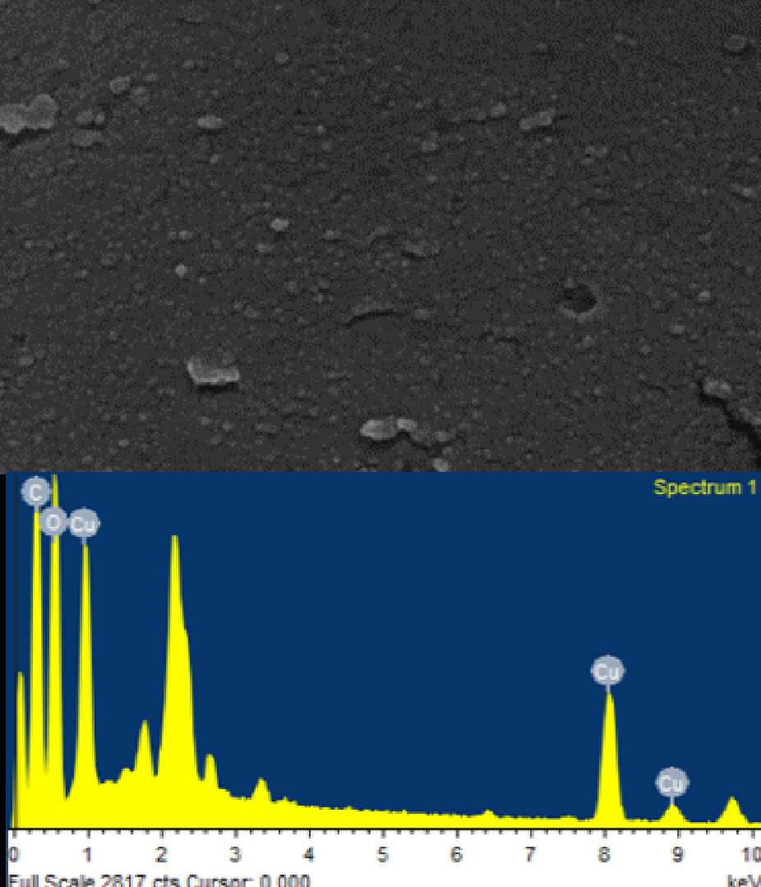

FIGURE 1. SEM and EDX visualization of the
synthesized copper nanoparticles [2]
- RESULTS AND DISCUSSION (12 pt)
  - Results (12 pt)
The Results should include the rationale or design of the experiments as well as the results of the experiments. Results can be presented in figures, tables, and text. The Results should include the rationale or design of the experiments as well as the results of the experiments. Results can be presented in figures, tables, and text.
  - Discussion (12 pt)
The Discussion should be an interpretation of the results rather than a repetition of the Results. The Discussion should be an interpretation of the results rather than a repetition of the Results. The Discussion should be an interpretation of the results rather than a repetition of the Results. The Discussion should be an interpretation of the results rather than a repetition of the Results. The Discussion should be an interpretation of the results rather than a repetition of the Results.
The Discussion should be an interpretation of the results rather than a repetition of the Results. The Discussion should be an interpretation of the results rather than a repetition of the Results. The Discussion should be an interpretation of the results rather than a repetition of the Results.
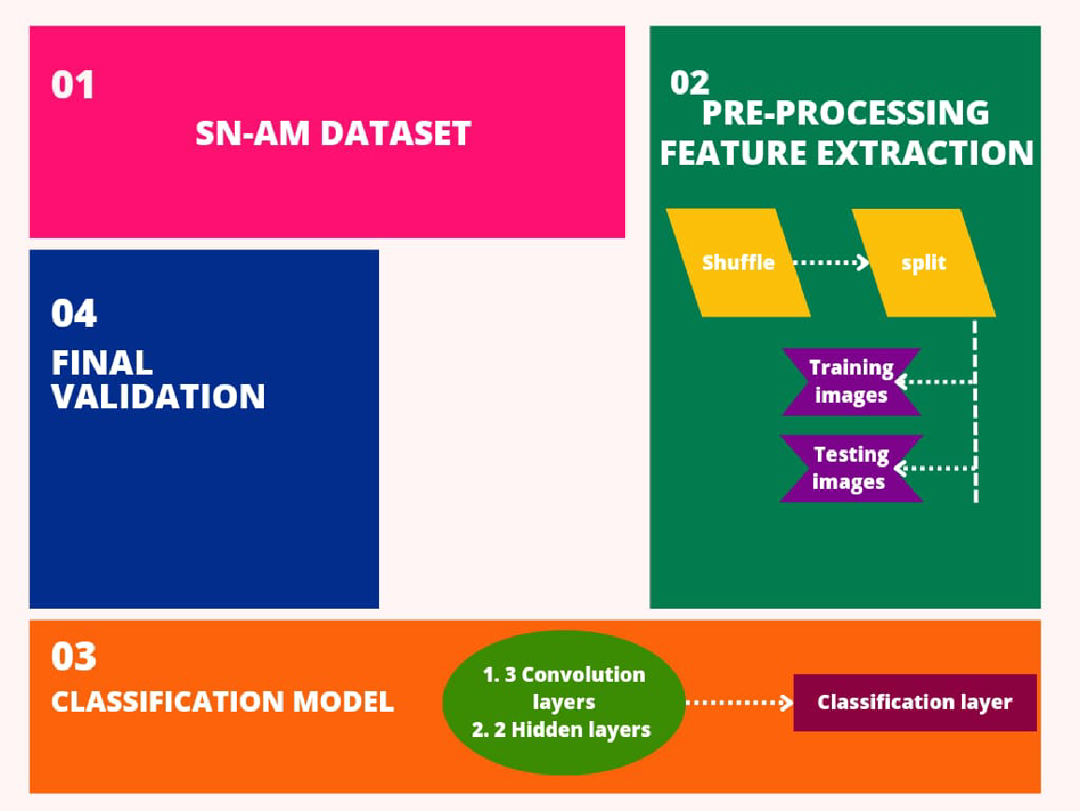
FIGURE 2. Process of the dataset [3]
CONCLUSION (12 pt)
The Conclusion should contain the confirmation of the problem that has been analyzed in result and discussion section. The Conclusion should contain the confirmation of the problem that has been analyzed in result and discussion section. The Conclusion should contain the confirmation of the problem that has been analyzed in result and discussion section.
ACKNOWLEDGEMENTS (12 pt)
Place Acknowledgments, including information on the source of any financial support received for the work being published. Place Acknowledgments, including information on the source of any financial support received for the work being published.
REFERENCES (12 pt)
The References section must include all relevant published works, and all listed references must be cited in the text. References should be written in the order of they appear in the text. Within the text, cite listed references use APA style, by their author last name and year (e.g., husnussalam (2010). The author(s) must check the accuracy of all cite listed reference, as the irjaeh Journal will not be responsible for incorrect in-text reference citations. International Research Journal on Advanced Engineering Hub (IRJAEH) adopts APA (American Psychological Association) for reference and citation in text. Authors can use various software to make it easier. All submitted papers in irjaeh Journal are suggested using Reference management applications such as Mendeley, Zotero or EndNote

Journal reference style:
- Birari, H. P., lohar, G. V., & Joshi, S. L. (2023). Advancements in Machine Vision for Automated Inspection of Assembly Parts: A Comprehensive Review. International Research Journal on Advanced Science Hub, 5(10), 365-371. doi: 10.47392/IRJASH.2023.065.
- Rajan, P., Devi, A., B, A., Dusthackeer, A., & Iyer, P. (2023). A Green perspective on the ability of nanomedicine to inhibit tuberculosis and lung cancer. International Research Journal on Advanced Science Hub, 5(11), 389-396. doi: 10.47392/IRJASH.2023.071.
- Keerthivasan S P, and Saranya N . “Acute Leukemia Detection using Deep Learning Techniques.” International Research Journal on Advanced Science Hub 05.10 October (2023): 372–381. 10. 47392/IRJASH.2023.066

References to papers accepted for publication but not yet published should show the journal name, the probable year of publication (if known), and they should state "in press."

